Birds Field Trip
Post-visit Questions

1. An “adaptation” is something an animal has or does that helps it live.
(Circle one): YES NO

2. Birds are the only animals with ____________. (Circle the word that fills in the blank.)
a) Wings
b) Feathers
c) Feet

3. What kind of beak would help a bird catch small frogs stuck in the mud? (Circle one)
a) Long and skinny
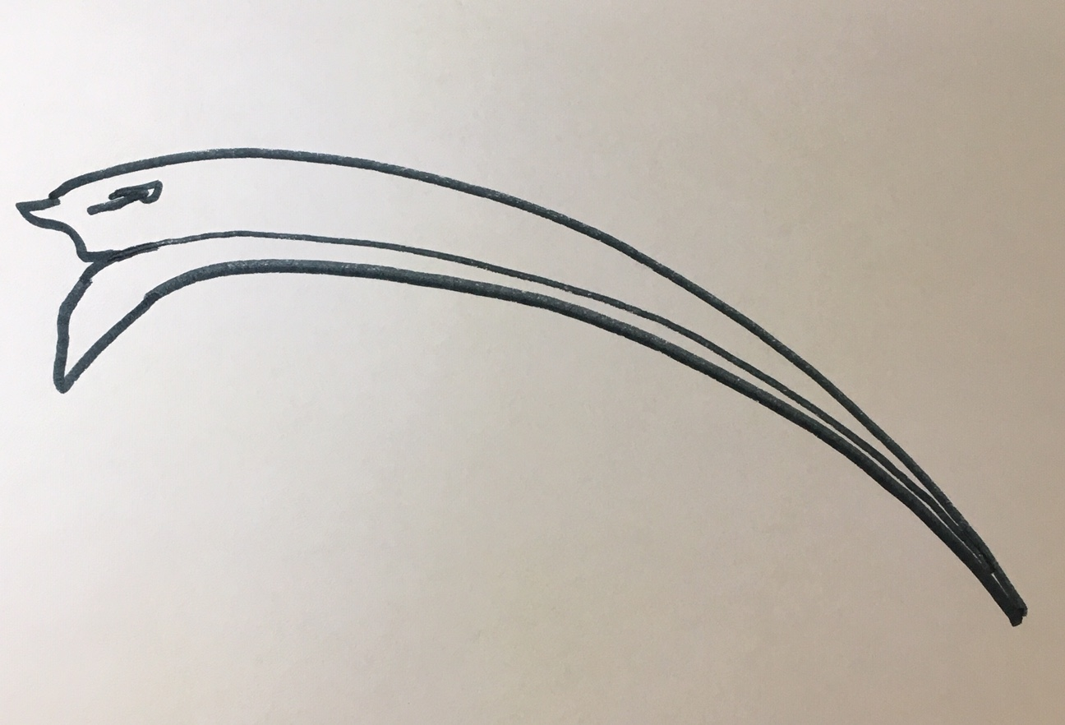
b) Curved like a hook
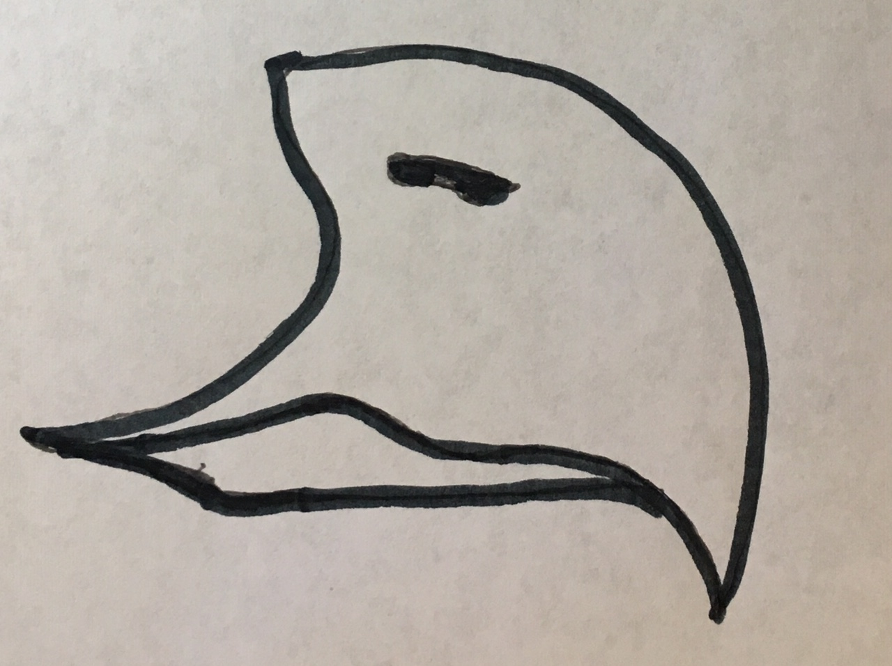
c) Short and strong
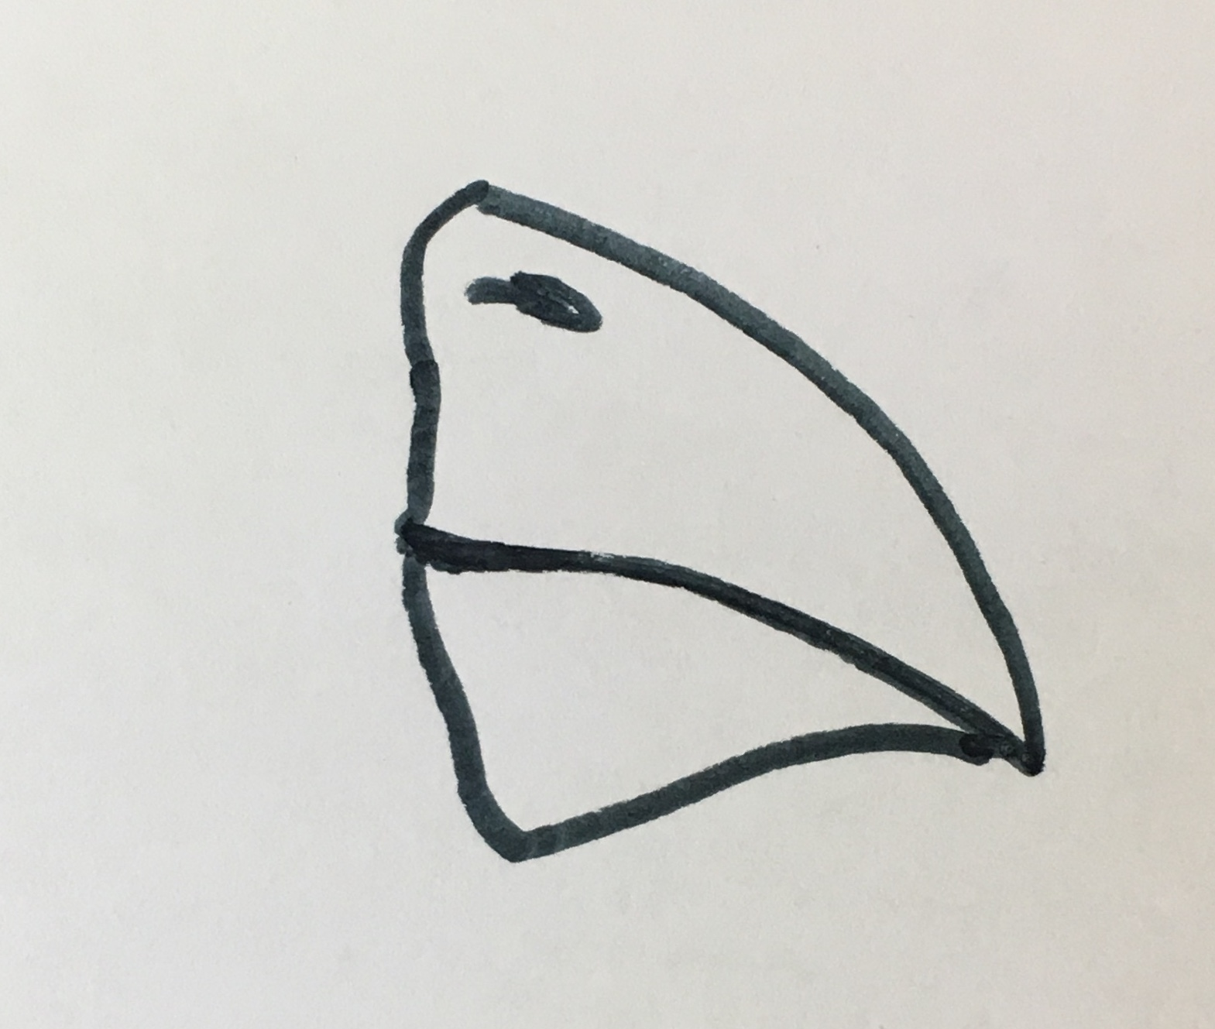

5. What kind of feather helps a bird stay warm? (Circle one)
a) Fluffy downy feather
b) Stiff tail feather
c) Curved wing feather

6. Which birds usually have the bright-colored feathers – males (boys) or females (girls)?

7. Draw a line from the bird to its food:

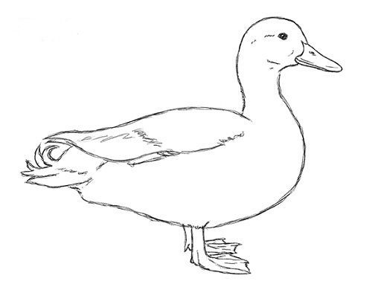Duck 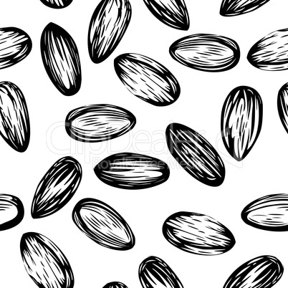 Seeds

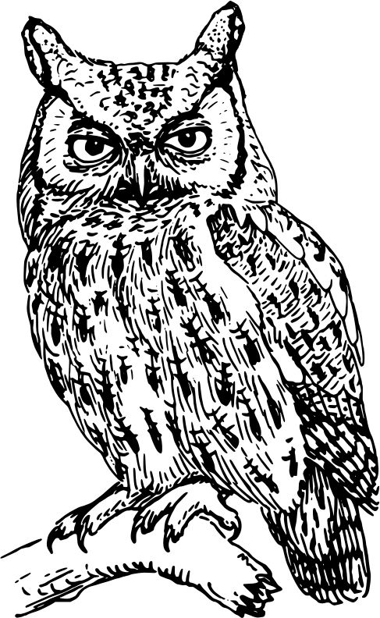 Owl 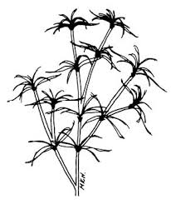Underwater plant

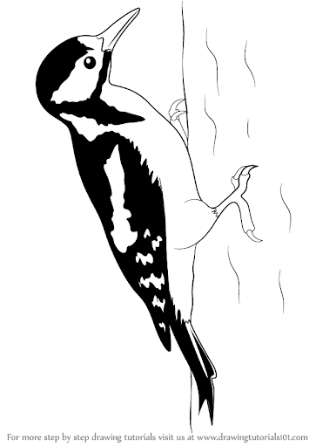Woodpecker 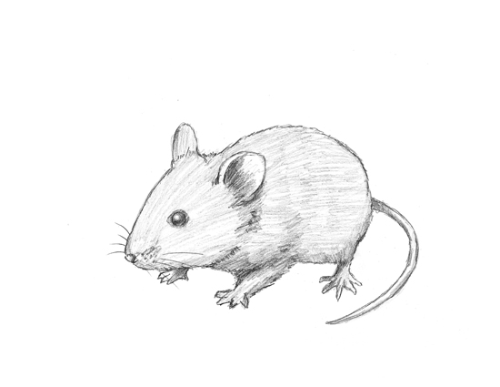Mouse
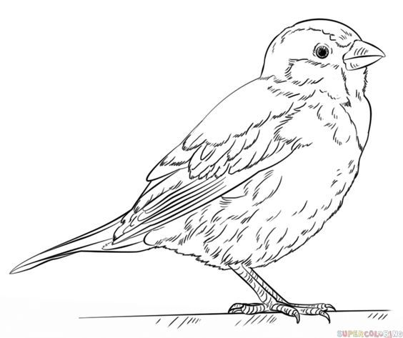Sparrow 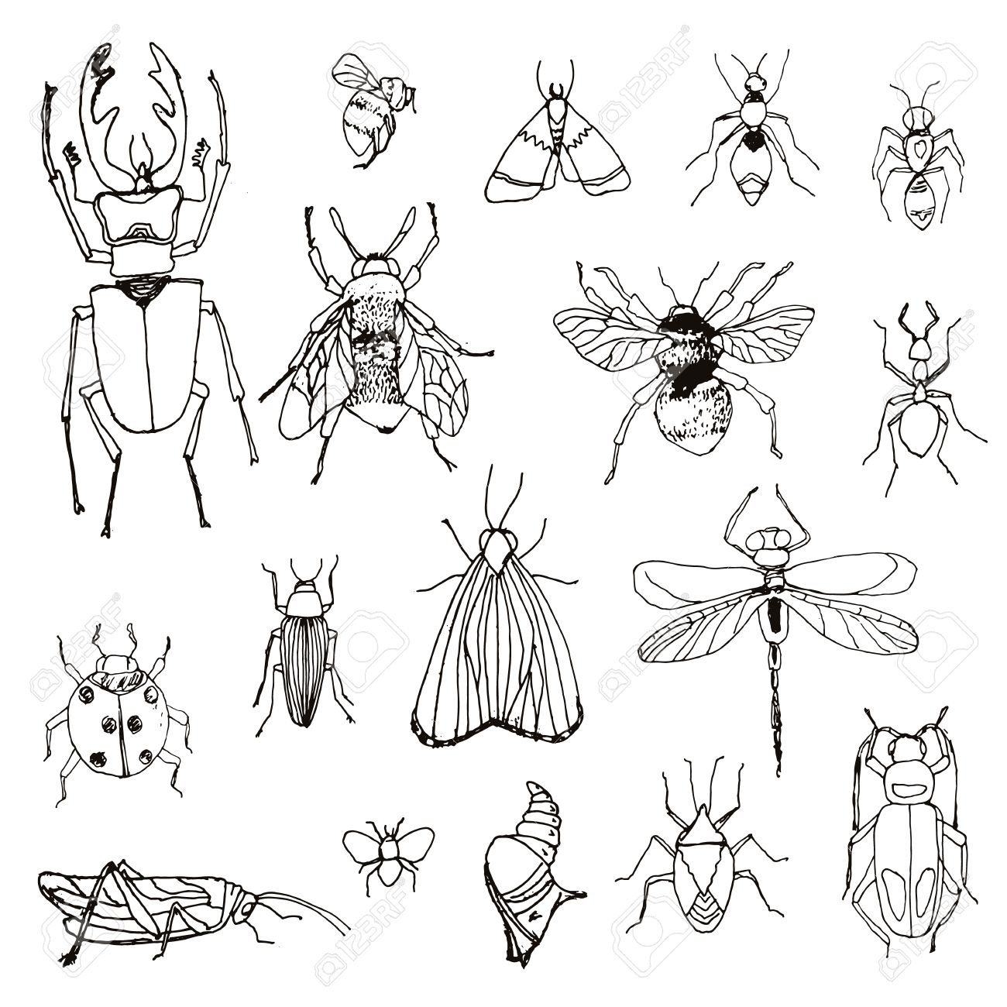Insects in tree bark

8. Birds use nests as places to __________________. (Circle the one that fills in the blank)

a) Sleep in winter.
b) Hatch eggs and raise a family.
c) Live the way people live in houses.

